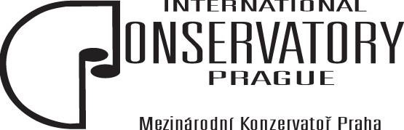

Maturitní otázky – Anglický jazyk
školní rok 2023/2024

- Places of interest for music/theatre lovers
- Culture life in the Czech Republic
- My future career
- Lifestyle of a professional musician/singer/actor
- Music – hobby or profession
- Education of music in the Czech Republic
- Going to concerts/to the theatre
- Music/theatre in my life
- Jobs in my fields
- My professional idol
- Playing in public
- Theatre buildings, concerts halls, opera houses
- My studies of music/acting
- Mass media
- Culture life in my place
- My studies at the conservatory
- Culture events
- Musical instruments
- Fashion and music style
- Auditions/casting, rehearsals, performances, concerts

Zpracovala Schválil
Mgr. Lucie Novoveská JUDr. Emil Ščuka
Pedagog předmětu Ředitel konzervatoře

